PADM 5302
Midterm Exam Name:
Spring 2021
Dr. Neubauer

Answer any three of the following five questions, drawing on your knowledge, the textbook, speaking notes, my video presentations and other resources including online resources. Respond to each part of each questions you choose to answer. Put you name on your work. Submit your work (as a Word or Adobe pdf file) on or before the due date in GaVIEW. Type into the boxes on this Word file and expand the boxes as needed.

1. On August 10, 2020 I took the following picture of the debt clock available here:
http://www.usdebtclock.org/

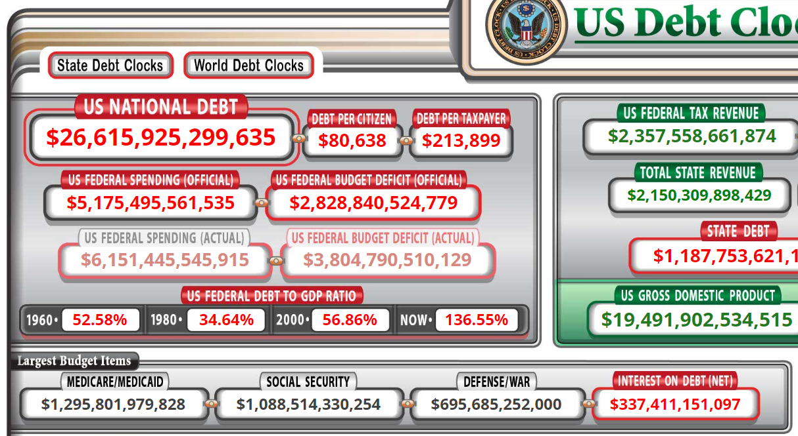

By how much has the US national debt increased since August 10, according to the "debt clock."

Given that interest payments on the national debt are among the largest budget items in the US National Budget, what are the implications for intergovernmental transfers of money from the national government to state and local governments in coming years?

Are interest payments on the national debt discretional or nondiscretionary? What would be the consequence if the national/federal government of the United States simply refused to continue paying interest payments on the national debt? (Keep in mind that the Treasury Department of the U.S. government is continually having to refinance debt instruments as they come due, and also has to issue new debt instruments to pay for additional new expenditures.)

Given the increase in the U.S. national debt from August 2020 (above) and what it is today, what do you estimate will the national debt will be three years from now?

2. Every organization and every jurisdiction of government needs sources of revenues necessary to exist and function. A good source of revenue for a unit of government is fair (in terms of its burden on citizens); is productive in terms of the amount of revenues it produces for the unit of government; and is not too costly/difficult to administer. Georgia and some other states derive some revenues from the sale of lottery tickets sold through gas stations and convenience stores. Assess this source of revenues in terms of fairness, the amount of revenues produced, and administrative burden for the state government to collect.

The sale of lottery tickets through the filling stations and convenience stores is considered to be a stable way of revenue collection in Georgia. However, this does not mean that Georgia is the only state that is using the sale of lottery to raise revenue, there are other cities but New York City is considered by many to be the veteran.
Lottery tickets are considered to be more biased in terms of the burden that it imposes on the low income earners as well as the poor when compared to the wealthy people (Michael, 2020). But, lottery collection has been pointed out to be one of the various main ways through which revenue can be generated. From the statistical data that was collected in the past, the increase of the lottery revenues is a plus to the cities that employ their use in order for them to raise revenue. According to my view, lottery sale as a source of revenue collection is a burden to the government because it benefits around a third of the overall jackpot earnings and therefore it is significant for the government to ensure that they have maintained a stable collection.

3. Why should a budget cycle begin with a realistic estimate of available revenues? Can meaningful decisions about spending be made in the absence of a realistic estimate of revenues? Why not? What is likely to happen during the budget year if the estimate of revenues to too "rosy?"

Realistic estimate revenues are the anticipated revenues that are to be collected from the different sources. Within every budget year, the sources from where revenues will come from are noted earlier before the period sets off. When such sources are not earlier, it tends to become easier for the calculation of the taxes that are to be paid. In addition, it also assist in the formulation of the financial reports as well as statements to the general public and the stockholders. In order for the companies to reach for meaningful decisions concerning spending, it is a must for there to be made realistic estimates (Brender, & Drazen, 2005). These estimates can only be made when at least there is a report indicated the projected revenues and the due taxes. Such data helps the financial managers by indicating the limits of expenditures that are to be incurred from the day-to-day running of the business.
Rosy revenue that is indicated within a certain budget year would immensely impact the organization in a positive manner because it will allow and pave way for a proper budgeting layout. This on the other hand would help the business in limiting the losses that might be possible to be incurred.

4. Explain what an incremental (marginal) approach to budgeting is, in contrast to a truly zero-based approach to budgeting. What are the benefits of incremental budgeting in terms of levels of political conflict and cognitive complexity?

An incremental (marginal) approach to budgeting refers to one of the traditional budgeting methods. According to this approach to budgeting, it is believed that the previous existing budget is one of the best. Additionally, the marginal approach to budgeting is thought that with some few changes made in the previous existing budget it can be made perfect for the purpose which is supposed to serve (Chinniah, 2013). On the other hand, in zero-based approach the budget that needs to be prepared will be developed from scratch.
One of the various budgets of the incremental budgeting is it ensures equity in the sense that it gives way or it allows for the equal increasing of the marginal changes that are made from one year to the next. Also, this approach of budgeting is simple as it only adopts the application of the budget that was previously formulated and thus ensuring stable financing over a certain period of time.

5. Please read this news report.

https://www.albanyherald.com/features/city-of-albany-faces-234-million-sewer-nightmare/article_ec75b7d6-97a4-11ea-aa37-3709c1551710.html

In 1954 (then) Albany City Manager Carey Burnett estimated the costs of correcting serious problems with the sewage disposal system to be about $4 million dollars. The problems were not corrected. The presently estimated costs to correct Albany's sewer system is over $200 million dollars.

In terms of politics and public budgeting, why was this problem not corrected years ago?

Reflect on the contents of the news report above, including the following statement by one of our City Commissioners.

“We’re talking about projects that, together, might add up to around $3 million-$4 million,” he said. “While that might not seem like much with a number like $234 million hanging over our head, it’s the kind of thing we have to do. We have to take a 10- to 20-year approach on getting this done.”

Our City Administrator has identified loans and government grants as possible sources of the revenues needed.

It seems to be unlikely under present fiscal circumstances that the national government or the government of the state of Georgia is going to provide a grant large enough to rework the city's sewer system as it should be reworked.

If you were a banker or an independent investor, would you loan the City of Albany $200 million or more to permanently rebuild the sewer system and stop spilling sewerage into the Flint river? Why or why not?

References
Brender, A., & Drazen, A. (2005). Political budget cycles in new versus established democracies. Journal of monetary Economics, 52(7), 1271-1295.
Chinniah, A. (2013). An Assessment of Zero-Based Budgeting to Protect the Leakage of Finance in Government and an Organizational Development. CLEAR International Journal of Research in Commerce & Management, 3(5).
Michael, W. (2020). State Lottery Revenue up $8.7M in August. arkansasonline, Retrieved from: https://www.arkansasonline.com/news/2020/sep/12/state-lottery-revenue-up-87m-in-august/?news-arkansas.

